**AIR CRAFT FUEL P­­­UMP SYSYTEM**

# Introduction :

Most modern aircraft have been improved such that most mechanical and electronic systems that operate different parts of the aircraft are automated and computer controlled. Pilots can control and monitor the entire systems and sub-systems of the aircraft within the cockpit. Control surfaces responsible for aircraft maneuvers are digitally controlled as well as the auto-pilot which is a common feature in most modern commercial aircraft are the possibilities of control systems engineering.

Application of control theory to an aircraft fuel system has a major impact on the fuel system performance and efficiency. In order to optimize the fuel system performance, a control system is incorporated which controls the fuel system components such as pumps, valves, vents, switches and sub-systems. Generally, most control operations are carried out by means of a control logic. A control logic is a schematic program designed to control a system by interconnecting the system devices in form of inputs and outputs.

The process of design is a highly technical procedure with regard to fuel supply and control monitoring of the fuel system. It is requirement to consider all technical difficulties that may arise from design, manufacturing and commissioning of the fuel system devices and processes. Depending on the type of aircraft and the operating range, various designs of the fuel system are considered. However, the critical requirement of the fuel system is to store and deliver fuel to the engine in adequate quantity and pressure without failure

Mathematical Modeling of Aircraft Fuel Pump :

The pump is a device that converts mechanical energy into fluid energy. It is used to transport, lift and increase or reduce pressure of fluid flow. There are different types and classifications of pumps but most modern aircraft use centrifugal pumps which are fitted inside the fuel tanks, variable displacement pumps and vane pumps which are engine powered pumps. The pump system model analysis in this section is concerned with basic mathematical model principle. An electric powered pump is a link between subsystems with voltage input which eventually produce the rotational output.

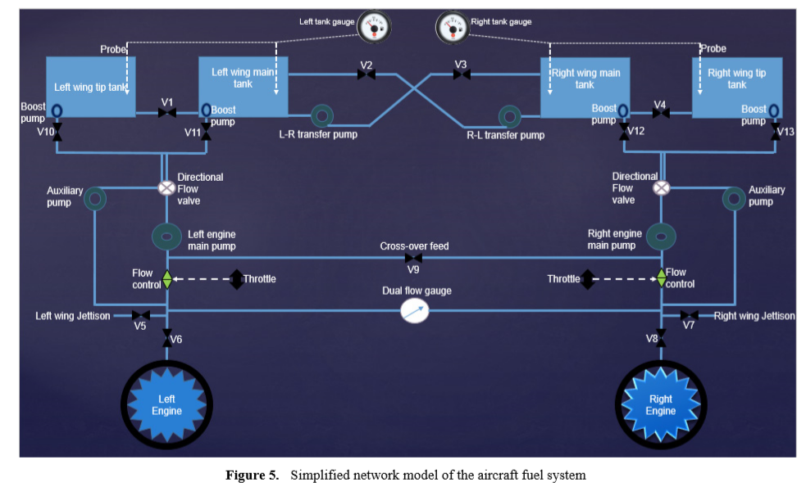

In order to model the pump process of the fuel system, an electrical circuit is designed to pass electric current to the electric motor. The motor transform electrical energy into rotational energy by means of electromagnetic induction. The rotational output of the motor is coupled with the shaft of the pump as input and the output speed is measured to provide information on the speed of the pump. Pump speed is required to provide sufficient flow as required by the main system.

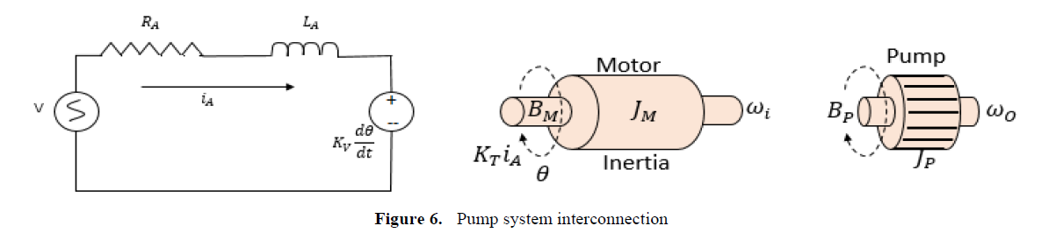

The mathematical model of the pump system is analysed using the variables as defined as follows:

V, input voltage, (volts)

𝑅A, armature resistance, (ohms)

𝐿A, armature inductance, (Henry)

𝑖A, armature current, (amps)

K, electromotive force, (NmAmp-1)

𝜔, angular speed of the shaft, (rads-1)

JM, moment of inertia of motor, (Kgm2S-2)

JP, moment of inertia of pump, (Kgm2S-2)

BM, friction of the motor, (Nms)

BP, friction of the pump, (Nms)

CONSIDERING THE ANGULAR VELOCITY TO BE THE OUTPUT

WRITING THE LOOP EQUATIONS

V=RAiA + LA. +k $\frac{dθ}{dt}$

KiA = Jm + Jp + +

=

Applying Laplace Transformation

V(s) = RAIA(s) +2LASIA(s) + ks -(1)

KiA(s)= Jmθ(s) + Jpθ(s) + $β_{m}$ Sθ(s) + $β_{p}$ Sθ(s) -(2)

Sθ(s)= $ω$ (s) -(3)

**Transfer Function =) $\frac{ω(s)}{V(s)}$ = $\frac{k}{k^{2}+\left(R_{A}+L_{A}S\right)[\left(J_{m}+J_{p}\right)S+\left(β_{m}+β_{p}\right)]}$**

We can verify the transfer function in matlab as follows

# State space equation

## $\left[\begin{aligned}di \\ dO \\ dw\end{aligned}\right]$ = $\left[\begin{matrix}-r/L & 0 & -k/L \\ 0 & 0 & 1 \\ k/(jm+jp) & 0 & -\frac{k}{(bm+bp)}\end{matrix}\right]\left[\begin{aligned}i \\ O \\ w\end{aligned}\right]$ + $\left[\begin{aligned}-\frac{1}{L} \\ 0 \\ 0\end{aligned}\right] V$

## y=[0 0 1] $\left[\begin{aligned}i \\ O \\ w\end{aligned}\right]$;

The values of physical parameters are

𝑅A, armature resistance, (ohms)=1

𝐿A, armature inductance, (Henry)=0.5

K, electromotive force, (NmAmp-1)= 0.01

JM, moment of inertia of motor, (Kgm2S-2)=0.01

JP, moment of inertia of pump, (Kgm2S-2) =0.05

BM, friction of the motor, (Nms) =0.005

BP, friction of the pump, (Nms)=0.05

­Transient analysis:

Step response:

using matlab we find out the curve

code:

Next, the poles, zeros have been found and the time response analysis with an impulse response has been done

**Impulse response:**

In the impulse response we can fine the residues and poles of the given transfer function.

**Root locus:**

Now, let us draw the root locus for the system and discuss stability of the system

We know function is

**G(s)= $\frac{0.01k}{0.03 s^{2}+0.065s+0.01}$**

**No of poles =m=2**

**No of zeroes=n=0**

No of asymptotes=a=m-n=2

ɵ=((2*x+1)/(m-n))*180

so, ɵ=90,270.

Centroid of asymptodes

Is =1.08335

Break away point=1.0833

From R.H criterion k should be always greater than 1 for the system to be stable

**Now lets verify root locus in matlab**

**Code:**

Next, we will plot the bode plot for the magnitude and phase vs frequency

Bode plot:

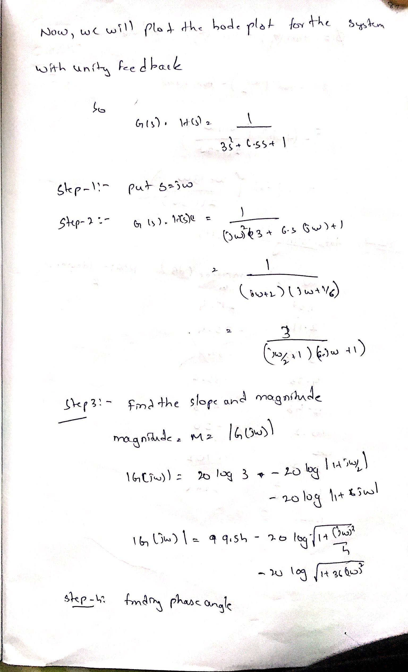

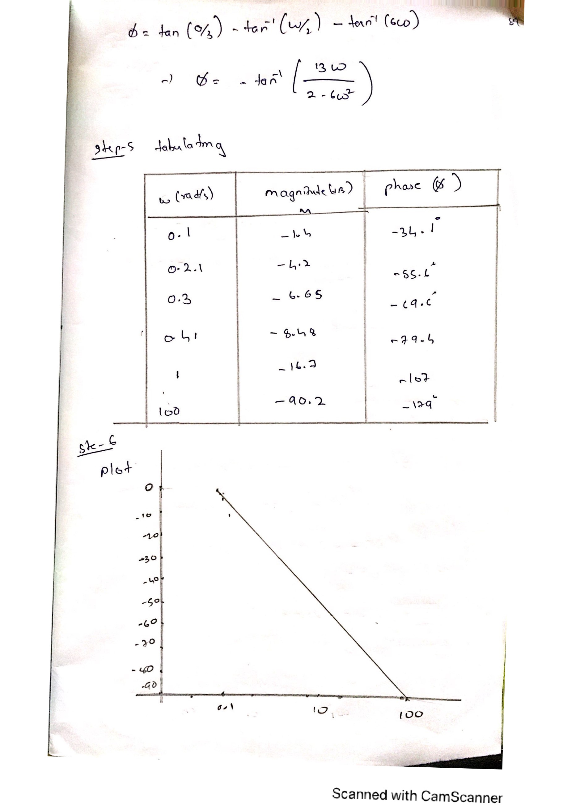

Scanned

with

CamScanner

Next, we will plot the Nyquist plot

But As the values of the magnitude are very less, the Nyquist plot is not plotted on paper. We can see it in matlab

Code:

Now, we know that N=P-Z

Where N=no of encirclements with the unit circle –1 + j0

As the plot is encircling it, N=1

P= no of poles on the right hand side of the imaginary axis

So, P=1

From this, Z=0

As Z=0 which infers that the system is stable

Now finally,we’ll check the controllability and stability of the system

**Conclusion** The system is fully controllable but not observable

**References:**

1.Mathematical Modeling and Simulation of a Twin- Engine Aircraft Fuel System by Ishola A. Afiz, Rachel Cunliffe , Talib Alukaidey